Name___________________________

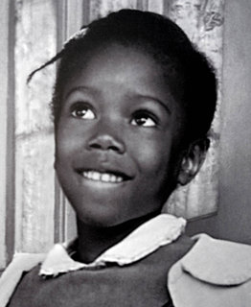

Excerpt from The Story of Ruby Bridges

Ruby Bridges was born in a small cabin near Tylertown, Mississippi. “We were very poor, very, very poor,” Ruby said. “My daddy worked picking crops. We just barely got by. There were times when we didn’t have much to eat. The people who owned the land were bringing in machines to pick the crops, so my daddy lost his job and that’s when we had to move.”

“I remember us leaving. I was four, I think.”

In 1957, the family moved to New Orleans. Ruby’s father became a janitor. Her mother took care of the children during the day. After they were tucked in bed, Ruby’s mother went to work scrubbing floors in a bank.

Every Sunday, the family went to church.

“We wanted our children to be near God’s spirit,” Ruby’s mother said. “We wanted them to start feeling close to Him from the very start.”

At that time, black children and white children went to separate schools in New Orleans. The black children were not able to receive the same education as the white children. It wasn’t fair. And it was against the nation’s law.

In 1960, a judge ordered four black girls to go to two white elementary schools. Three of the girls were sent to McDonogh 19. Six-year-old Ruby Bridges was sent to first grade in the William Frantz Elementary School.

Ruby’s parents were proud that their daughter had been chosen to take part in an important event in American history. They went to church.

“We sat there and prayed to God,” Ruby’s mother said, “that we’d all be strong and we’d have courage and we’d get through any trouble; and Ruby would be a good girl and she’d hold her head up high and be a credit to her own people and a credit to all the American people. We prayed long and we prayed hard.”

1. Why couldn’t black children go to school with white children?

O It wasn’t fair.

O It was against the law.

O There weren’t any white schools to go to.

1. According to the passage, why did Ruby’s family have to move?

O They were very poor.

O She needed to go to a white school.

O Her father lost his job.

1. How did Ruby’s parents feel about her being chosen to go to a white school?

O proud

O angry

O scared

1. Ruby’s mom prayed that she would “hold her head up high”. What does that mean?

O stand up straight and tall

O be proud of who she is

O stay awake

Ruby’s parents prayed for her before she started at her new school. Name three things Ruby’s parents included in their prayer. Why do you think they prayed for those things?

____________________________________________________________________________________________________________________________________________________________________________________________________________________________________________________________________________________________________________________________________________________________________________________________________________________________________________________________________________________________________________________________________________________________________________________________________________________________________________________________________